A Secret Unwittingly Revealed
By Howard “Cork” Hayden, The Energy Advocate, February 2026

Sunlight brings heat to the earth, and infrared radiation (IR) going to space cools the planet. Some IR is trapped by the atmosphere. Even Al Gore understood that much way back in 2006 when his movie An Inconvenient Truth (from which the nearby picture was extracted) was released. Wouldn’t it be nice if climate-modelers knew that much! Unfortunately, they do not.

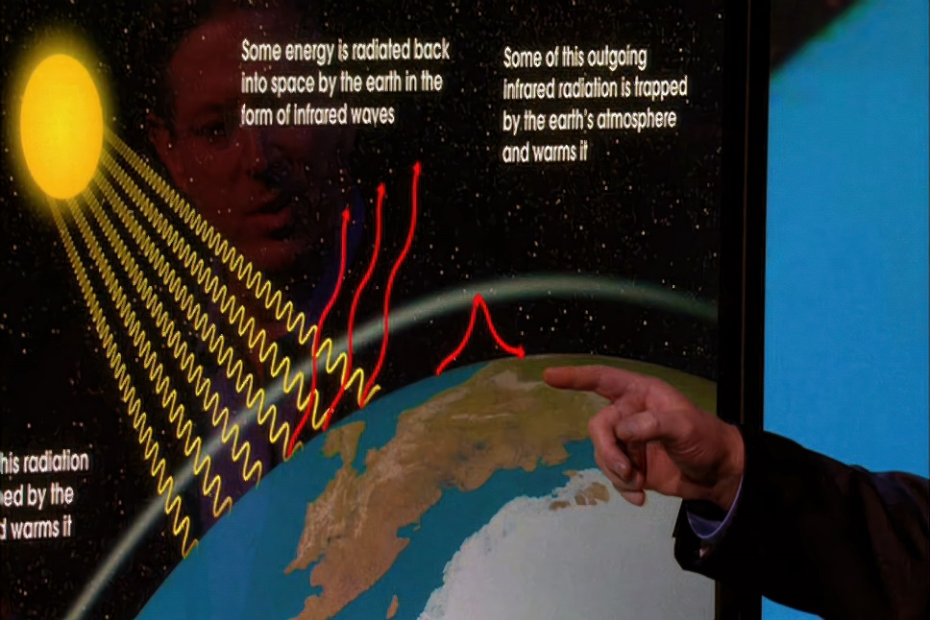

Let us begin at the beginning. Greenhouse gases do not cause hurricanes, sea-level rise, tornadoes, floods, droughts, ice storms, glacial melting, torrential rains, polar vortices, blizzards, El Niños, La Niñas, or any other type of weather disaster. Their ONE AND ONLY effect is to act on outgoing IR via the greenhouse effect. Changes in greenhouse gas concentrations cause changes in outgoing IR. Unbeknownst to Mr. Gore, the greenhouse effect is very much wavelength dependent.

You would imagine that the mechanism(s) by which IR interacts with the atmosphere would be the main concern of scientists who model the climate.

But you would be wrong.

No, climate models are based on nothing but (real or imagined) correlations. The secret has been given away in a publication by phys.org [1]:

Reliable predictions of how the Earth's climate will respond as atmospheric carbon dioxide levels increase are based on climate models. These models, in turn, are based on data from past geological times in which the CO2 content in the Earth's atmosphere changed in a similar way to today and the near future. [Emphasis added.]

The surface of our planet emits an average of 398 W/m2, but only about 239 W/m2 goes to space because of those greenhouse gases in the atmosphere. You would think that climatologists would fly balloons to measure how much IR exists at what altitude and what temperature.

But you would be wrong. They have never done so.

An increase in the concentration of any greenhouse gas ought to cause a decrease in the amount of IR going to space. You would expect the climate scientists who contribute their wisdom to the IPCC would cite numerous measurements of IR intensity made by satellites looking down to show the decrease in IR.

But you would be wrong.

There has been precisely one experiment that has compared the quantity of IR emitted to space from time to time. The CERES project [2] found that the amount of IR emitted to space has increased over time. Did you ever lose heat faster by putting on a blanket?

Carbon dioxide (CO2, known euphemistically as “carbon”) interacts with IR in a certain region of the IR spectrum. Increasing CO2 concentration should therefore cause some change in the spectrum of IR going to space. You might therefore believe that climate scientists would publish measured “before and after” IR spectra to show exactly that phenomenon.

But you would be wrong.

The IPCC has never—repeat, never—published so much as a single spectrum of measured outgoing IR. No BEFORE spectra, no AFTER spectra. Zero spectra.

See those cute little red wavy arrows that Al Gore’s fingers point to? They represent IR leaving the surface. The quantity is calculable from the surface temperature using the Stefan-Boltzmann law, which is to be found in every elementary physics book on the planet. As the surface temperature increases, the IR flux from the surface increases by about 5.5 W/m2 for every 1ºC of temperature rise. If a given model predicts a 4ºC temperature rise, the models surely need to explain how the increase of 22 W/m2 in IR emission is inhibited by that much increase in the greenhouse effect. Since this IR emission involves nothing very complicated, you would naturally assume that every climate model would account for it.

Again, you would be wrong. Every single model ever published simply ignores this simple calculation. Evidently, elementary physics is beneath IPCC’s dignity.

[1] “New temperature record challenges extreme high-latitude warmth paradigm,” edited by Gaby Clark, reviewed by Robert Egan, Jan 16, 2026, https://phys.org/news/2026-01-temperatureextreme-high-latitude-warmth.html

[2] Norman G. Loeb talk to CERES staff, “Observational Assessment of Changes in Earth’s Energy Imbalance Since 2000,” https://ceres.larc.nasa.gov/documents/STM/2023-05/15_Loeb_Contributed_Science_Presentation_2023.pdf

