The Thumb on the Scale
By Howard Hayden, The Energy Advocate, January 2024

The dinosaurs lived when the average global temperature was 6ºC to 10ºC warmer than it is now, so you might think that there has been some climate change since that time. According to the UN Framework Convention on Climate Change (UNFCCC), you would be wrong. UNICEF explains why you are wrong by presenting the news that youngsters don’t know what the definition of climate change is [2]:

Most children and young people say they have heard of climate change but only half understand what it is, according to a new UNICEF-Gallup poll, as world leaders gather at this year’s COP28.

The global poll found that on average, 85 per cent of young people aged 15-24 surveyed in 55 countries said they have heard of climate change, yet just 50 per cent of those chose the correct definition as per the United Nations Framework Convention on Climate Change (UNFCCC) when asked to select between “seasonal changes in weather that occur every year” and “more extreme weather events and a rise in average world temperatures resulting from human activity”. [Boldface and italics added.]

They might well have asked, “Would you rather walk or take your lunch?”

You see, the UNFCCC has a very explicit definition of climate change that automatically implicates humans [3]”

‘Climate change’ means a change of climate which is attributed directly or indirectly to human activity that alters the composition of the global atmosphere and which is in addition to natural climate variability observed over comparable time periods. [Emphasis added.]

To make sure that everybody understands that humans are responsible for climate change, the UNFCCC’s “Science” Introduction says [4]:

The science on climate change is clear. There is no question that these abnormal changes result from global warming due to an increased greenhouse effect caused by the vast amounts of greenhouse gases added to the atmosphere by human activities. [Emphasis added.]

All that stuff that occurred in the half-billion years of the Phanerozoic Era before humans ruined the planet, as illustrated in Figure 3, is called climate variability by the UNFCCC; there was no climate change until very recently.

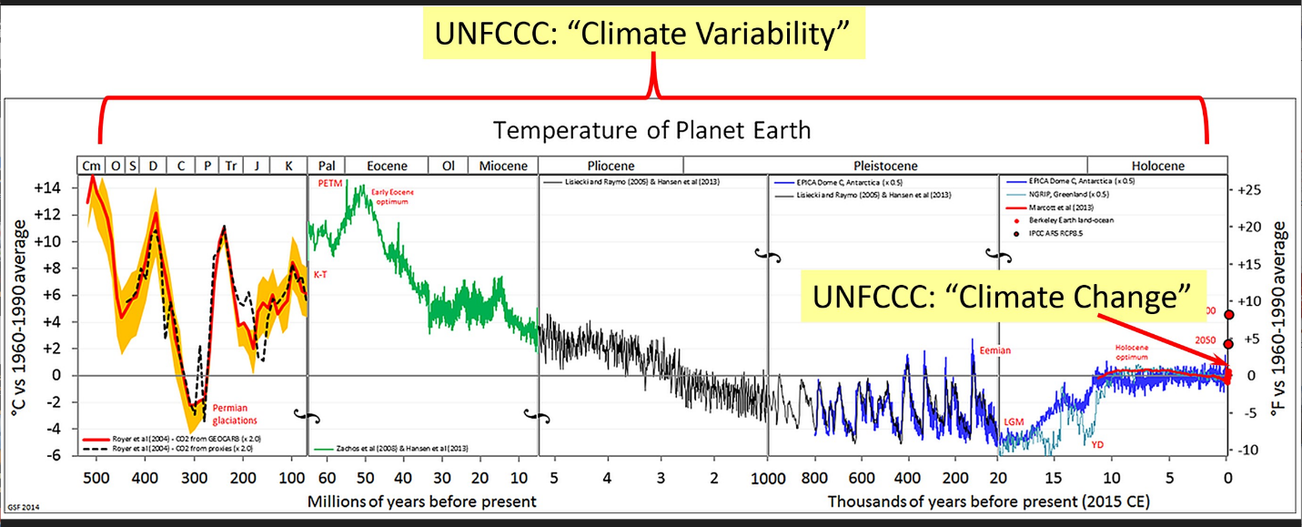
Figure 3: UNFCC Definitions [Note the change scale of the time line]

Of course, no God of Vocabulary ever came down and chiseled a definition of Climate Change (or anything else) into stone; UNFCCC’s actions—writing an official definition into the annals of International Government—introduced an automatic bias, so that you can’t say that that climate change has always happened on the planet. It couldn’t have happened, because there were no humans to cause it.
….

[2] Tess Ingram,” Only half of young people able to identify correct definition of climate change – UNICEF, Gallup: Findings highlight urgent need to protect and invest in children, including in climate education, in decisions at COP28,”,12/7 2023
[3] Article 1: Definitions https://unfccc.int/resource/ccsites/zimbab/conven/text/art01.htm
[4] https://unfccc.int/topics/science/the-big-picture/introduction-science

